**DEPARTMENT GRIEVIANCE MANAGEMENT**

**Project Report Submitted**

**To**

**Gujarat University**

**In partial fulfilment of the requirements for**

**the award to the Degree of**

**5 YEAR INTEGRATED MASTER OF SCIENCE (COMPUTER SCIENCE)**

**SEMESTER –**VII

GUIDED BY: SUBMITTED BY:

**Dr. Hiren Joshi Janvi Chauhan (70002)**



**DEPARTMENT OF COMPUTER SCIENCE**

**GUJARAT UNIVERSITY, AHMEDABAD**

**YEAR: 2022-23**

**ACKNOWLEDGMENT**

With immense gratitude, I extend my heartfelt thanks to those who have been pivotal in the realization of the Department Grievance Management. The successful completion of this project stands as a testament to the collective efforts of individuals who have generously offered their support and inspiration, both directly and indirectly.

A special acknowledgment goes to Dr. Hiren Joshi , Head of the Department of Computer Science at Gujarat University . Dr. Hiren Joshi provided us with a robust platform, affirming an environment where learning could be nurtured and translated into practical implementation. My sincere appreciation also extends to my internal guide, Dr. Hiren Joshi, Professor at the Department of Computer Science, Gujarat University. Dr. Hiren Joshi 's keen interest, guidance, and unwavering supervision at every stage of the project have been instrumental in shaping its current form.

In conclusion, I express gratitude to everyone, whether directly or indirectly involved, for their contributions to the project. Your support has been a cornerstone in the successful development of The Department Grievance Management.

**With Thanks to All**

Janvi Chauhan

**TABLE OF CONTENT**

Department of Computer Science

2

Project Profile.............................................4

Project Description......................................5

Tools and Language.....................................10

System Design.............................................11

Data Dictionary...........................................17

Screenshots................................................23

Conclusion………………………………..40

Future Work...............................................41

Bibliography...............................................42

**PROJECT PROFILE**

|  |  |
| --- | --- |
| **Title** | **Description** |
| Project Title | Department Grievance Management |
| Aim of Project | Addressing concerns and complaints regarding various aspects of our department's facilities and services |
| Project duration | 6months |
| Team size | 1 Members |
| Tools used | Visual Studio code,Github |
| Technologies used | HTML,CSS,Javascript,Ajax,PHP,XAMPP,  MySQL |
| Software and hardware environment requirement to use for an application | Any modern web browser is compatible with HTML,CSS and JavaScript |
| Guide | Dr Hiren Joshi |

**Project Description**

Department of Computer Science

2

* The Department Grievance Management System is designed to serve as a comprehensive platform for addressing concerns and complaints regarding the various aspects of our department's facilities and services. With a focus on creating a supportive and conducive environment, this system aims to streamline the grievance submission and resolution process. By providing a centralized hub for managing complaints, we seek to enhance communication, accountability, and overall satisfaction within the academic community.
* With the user-friendly interface, students can easily submit complaints regarding various issues they encounter within the department. Whether it's a malfunctioning computer, a cleanliness issue in the restroom, or any other concern impacting their experience, our platform provides a straightforward mechanism for voicing these grievances.
* The primary objectives of the Department Grievance Management System are to create an efficient process that reduces the time and effort required to submit and resolve grievances, ensuring that issues are addressed promptly and effectively. By making the status and resolution of complaints visible to all stakeholders, the system fosters transparency, trust, and accountability.

* **Functional Requirements of the System**

**1)User Authentication and Authorization**

* Users can login as per the requirements and they can manage their profile .
* User can update or edit their profile information such as their email , name and password.
* There are different Roles based on specific permissions such as Admin, Faculty and Student.

**2)Grievance Submission**

* Students can submit the grievances based on their issues and category of grievance.
* The Grievance submission form consists of the complaint ID ,Description and any relevant attachments.

**3)Grievance Tracking**

* Tracking of the complaints/grievances as students can see the status of the grievance.

**4)Categoraization of the Grievance**

* Different Categories of the complaints are provided .
* System allows user to choose the categories as per the nature of the grievance(Laboratory ,Library,Infrastructure etc).

**5)Reporting**

Report of the grievances which are in the system .

**6)Searching and Filters**

Using the Search ability for searching the complaints .

Users must be able to search and filter complaints based on various parameters (e.g., category, status, date).

**7)Notification**

* Notifications are sent to faculty when an admin assigns a complaint.
* **Non-Functional Requirements of the System**

**1)Usability**

* User friendly interface providing smoother interaction with the students as well .

**2)Performance**

* The system is geared for smaller-scale activities, but once the number of users or data volume approaches 1,000, performance issues such as longer response times, slower query execution, and potential system lag may arise.

**3)Compatibility**

* The system is compatible with various web browsers .

**4)Maintainability**

* To be well coded and documented so that it will be better to maintain.

**PROJECT DESCRIPTION**

* Functionalities of the Users

1. Student

* Generates Grievance
* Uploads media file such as pdf,jpeg,jpeg and png files
* View Status
* View Grievance

1. Faculty

* View Grievance
* Update Status
* Handling the grievances according to the category .
* Handling the grievances according to assignment.
* Delete Grievance
* Generate Reports

1. Admin

* View Grievance
* Manages Users
* Manages Grievance
* Validate the grievance status
* Can Assign the faculty to the particular category or grievance
* Generates the report on the basis of the grievance received
  + such as number of grievances filed , categories of grievance and status of grievance

**Languages & Tools**

* **Frontend**
* **HTML:** Used to structure the content on the web pages.
* **CSS:** Employed for styling and designing the user interface to ensure it is visually appealing and consistent. Using this to provide proper representable interface and smooth interaction as well as for better aesthetics to style and design landing pages for users to easily interact.
* **JavaScript:** Utilized to create interactive elements, enhance user experience, and enable dynamic content updates on the web pages. Providing minimal features to help provide a solid foundation for the system.
* **PHP :**  
  Although primarily a server-side language, PHP supports the frontend by dynamically generating HTML content, integrating user-specific data, and ensuring dynamic updates on the web pages. For example, PHP is used to embed user details, grievances, or category-specific content directly into the frontend interface.
* **Server-Side Scripting** :  
  Server-side scripting complements the frontend by delivering pre-rendered and dynamically updated pages to the client. It ensures that users view personalized content and enables secure data retrieval and display on the frontend.
* **Web Server** :  
  The webserver facilitates the frontend by delivering HTML, CSS, JavaScript, and other assets to the user's browser. It serves as the bridge, ensuring smooth communication between the backend processing and the frontend display.
* **Bootstrap :** Bootstrap enhances the frontend by providing a responsive grid system, pre-designed components, and utility classes to streamline layout design and styling. It ensures that web pages are mobile-friendly and visually consistent, offering interactive elements like modals and dropdowns through built-in JavaScript plugins. This simplifies creating dynamic, user-friendly interfaces without extensive custom code.
* **Backend**
* **SQL:** Utilized to manage and query the database, ensuring efficient storage, retrieval, and manipulation of complaint data. SQL is used to handle all database operations, including storing complaint details, tracking their status, and generating reports. Sql queries helping in fetching the data required each time and also helping to manipulate the data at the same time directly from frontend rather than changing it in table from phpmyAdmin.

**SOFTWARE**

**DESIGN**

* **Use Case**
* **Admin**

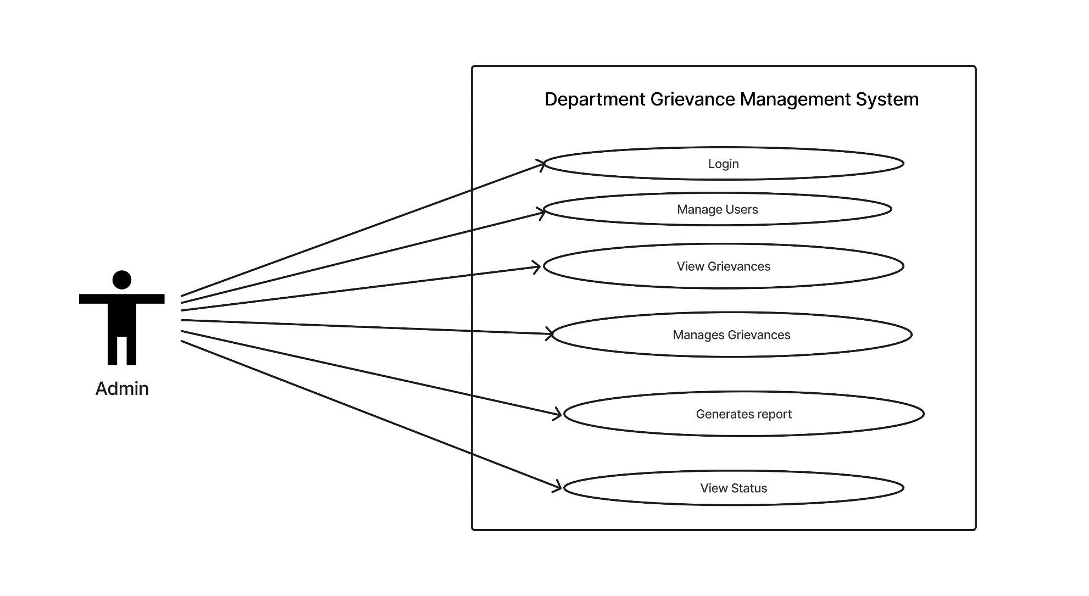

* **Faculty**

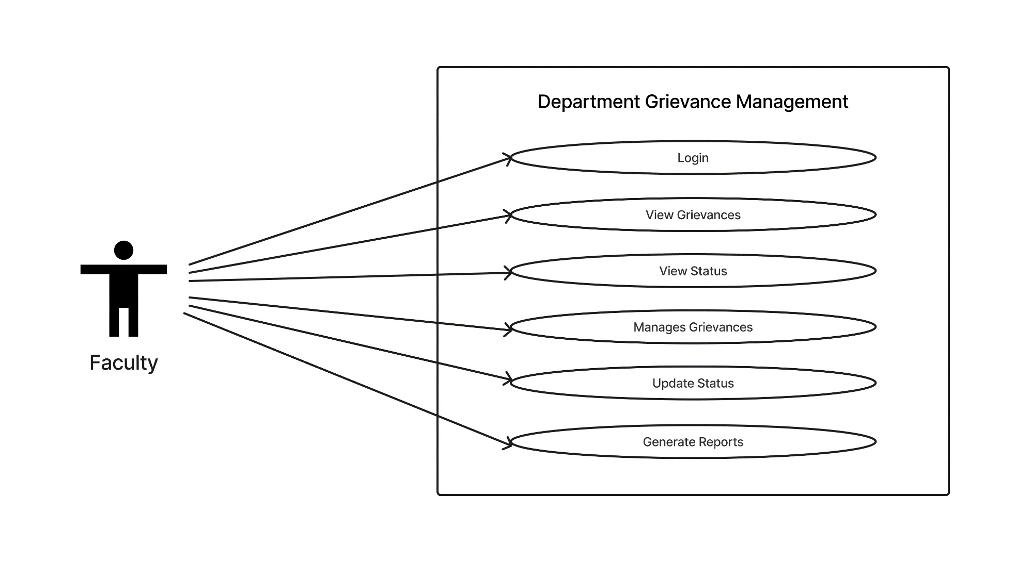

* **Student**

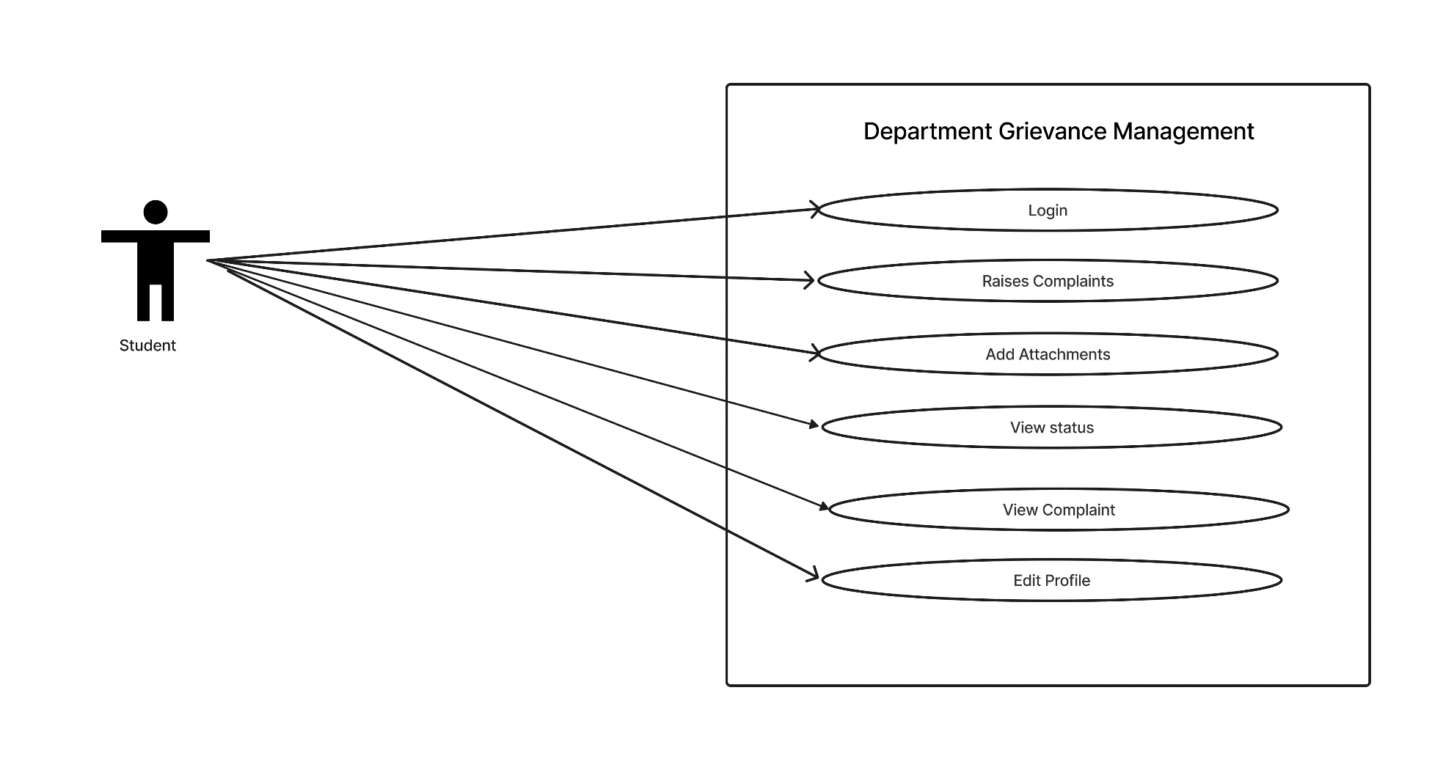

* **Activity DIAGRAM**

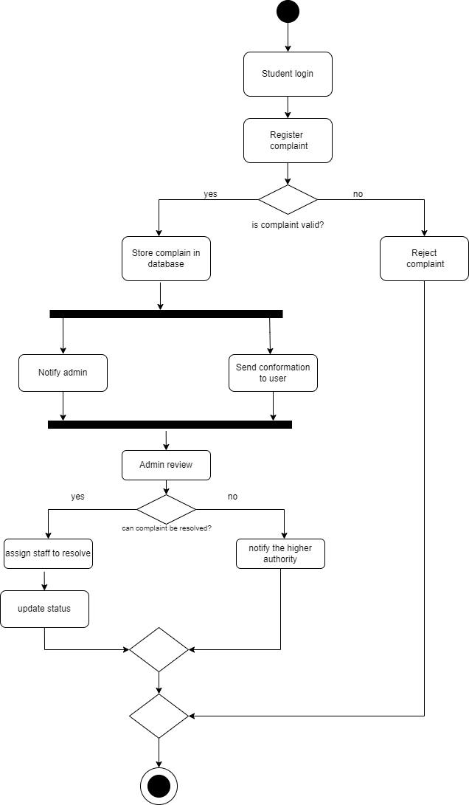

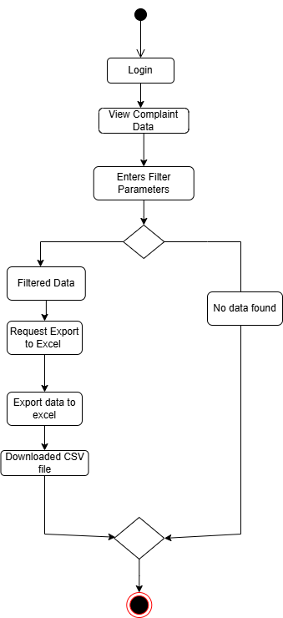

* **CLASS DIAGRAM**

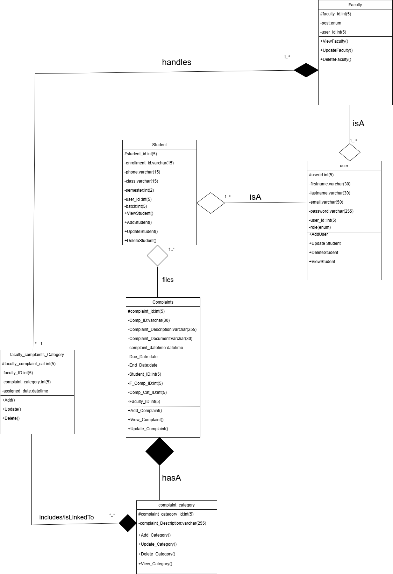

* **Sequence DIAGRAM**

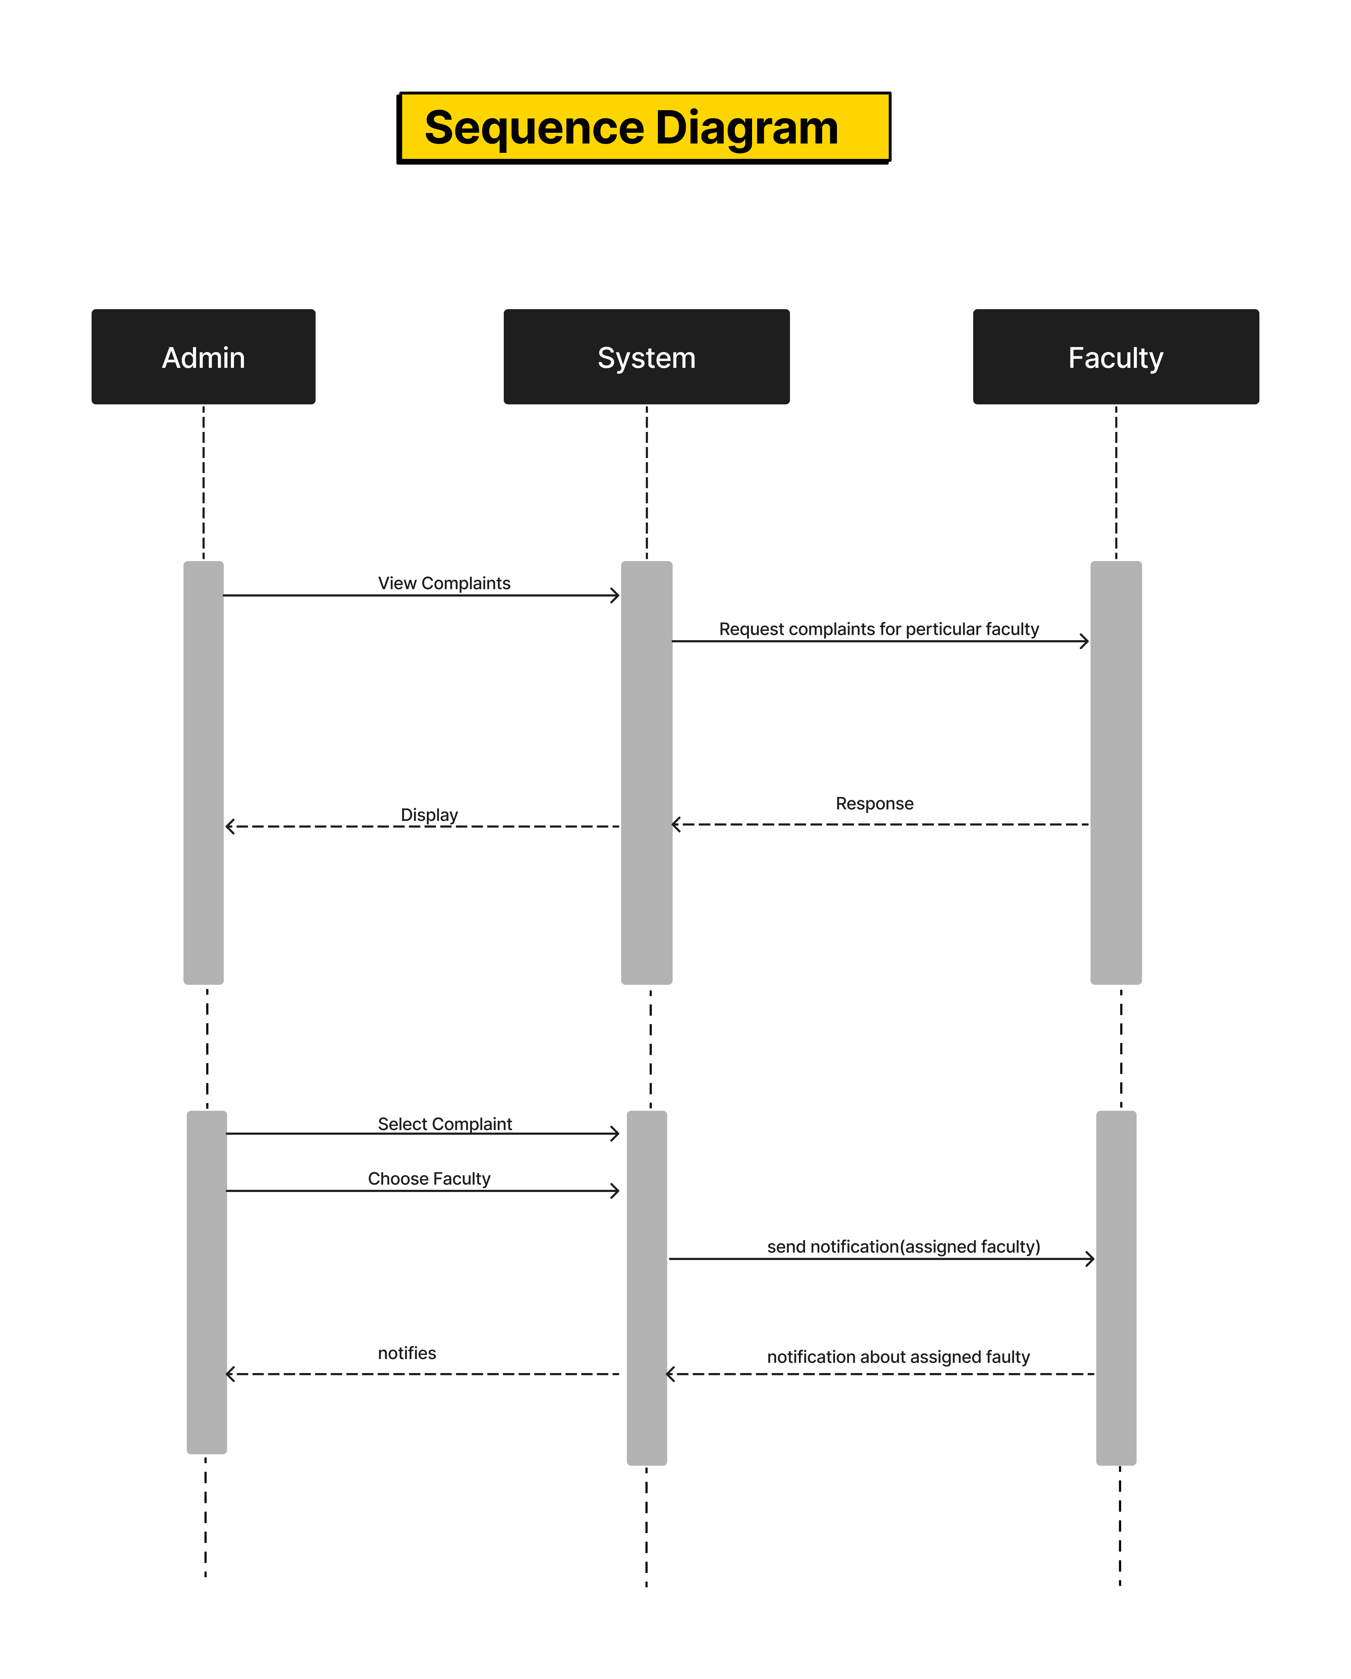

* **Pictorial Representation of the System Flow**

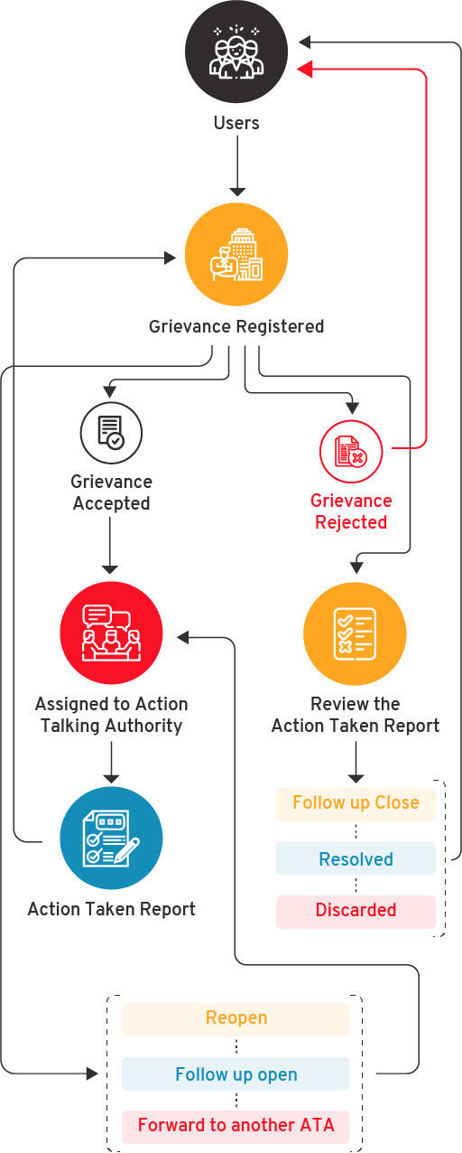

**DATA DICTIONARY**

**Data Dictionary**

* **User Table**

|  |  |  |  |  |  |  |
| --- | --- | --- | --- | --- | --- | --- |
| Serial no | Field name | Type | Size | Link to | Constraints | Sample data |
| 1 | user_id | INT | 5 |  | Primary Key | 12 |
| 2 | firstname | VARCHAR | 30 |  |  | Kathan |
| 3 | lastname | VARCHAR | 30 |  |  | Sharma |
| 4 | email | VARCHAR | 50 |  | Unique key | kathan@email.com |
| 5 | password | VARCHAR | 255 |  |  |  |
| 6 | role | ENUM |  |  |  | Admin |

* **Complaints Table**

|  |  |  |  |  |  |  |
| --- | --- | --- | --- | --- | --- | --- |
| Srno | Field name | Type | Size | Link to | Constraints | Sample Data |
| 1 | complaint_id | INT | 5 |  | Primary Key | 10 |
| 2 | Comp_ID | VARCHAR | 11 |  |  | E-265533760 |
| 3 | Complaint_  Description | VARCHAR | 255 |  |  | System 116 in lab 3 not working. |
| 4 | Complaint_  Document | VARCHAR | 100 |  |  | ./uploads/complaint.pdf |
| 5 | complaint_datetime | DATETIME |  |  |  | 2024-05-04 21:02:57 |
| 6 | Due_Date | DATE |  |  |  | 2024-05-04 |
| 7 | End_Date | DATE |  |  |  | 2024-05-19 |
| 8 | Status | Enum |  |  |  | Pending,Processing,Resolved |
| 9 | Student_ID | INT | 5 | Student->student_id | Foreign Key | 1 |
| 10 | Faculty_ID | INT | 5 | Faculty->faculty_id | Foreign  Key | 2 |
| 11 | F_Comp_ID | INT | 5 | Faculty_complaints  _cat->faculty_complaint_  cat | Foreign Key | 3 |
| 12 | Complaint_Cat_ID | INT | 5 | Complaint_category->complaint_category_id | Foreign Key | 10 |

* **Complaint_category Table**

|  |  |  |  |  |  |  |
| --- | --- | --- | --- | --- | --- | --- |
| Serial no | Field name | Type | Size | Link to | Constraints | Sample Data |
| 1 | Complaint_category_id | INT | 5 |  | Primary Key | 11 |
| 2 | Category_description | VARCHAR | 30 |  |  | Cleaning and management |

* **Student Table**

|  |  |  |  |  |  |  |
| --- | --- | --- | --- | --- | --- | --- |
| Serial no | Field name | Type | Size | Link to | Constraints | Sample Data |
| 1 | student_id | INT | 5 |  | Primary Key | 11 |
| 2 | enrollment_id | VARCHAR | 15 |  |  | STU98765 |
| 3 | phone | VARCHAR | 15 |  |  | 1234567653 |
| 4 | class | VARCHAR | 30 |  |  | Msc(Cs) |
| 5 | semester | INT | 2 |  |  | janvi@gmai.com |
| 6 | batch | INT | 2 |  |  | 2 |
| 6 | user_id | INT | 5 | user->userid | Foreign Key | 43 |

* **Faculty Table**

|  |  |  |  |  |  |  |
| --- | --- | --- | --- | --- | --- | --- |
| Serial no | Field name | Type | Size | Link to | Constraints | Sample Data |
| 1 | faculty_id | INT | 5 |  | Primary Key | 14 |
| 2 | post | ENUM |  |  |  | Assistant Professor |
| 6 | user_id | INT | 5 | user->user_id | Foreign Key | 17 |

|  |  |  |  |  |  |  |
| --- | --- | --- | --- | --- | --- | --- |
| Serial no | Field name | Type | Size | Link to | Constraints | Sample Data |
| 1 | faculty_  complaint_cat | INT | 5 |  | Primary key | 1 |
| 2 | Faculty_ID | INT | 5 | faculty->faculty_id |  | 8 |
| 3 | Complaint_  Category_ID | INT | 5 | Complaint_category_ID |  | 1 |

* **Faculty_complaint category Table**

SCREENSHOTS

* Login Form

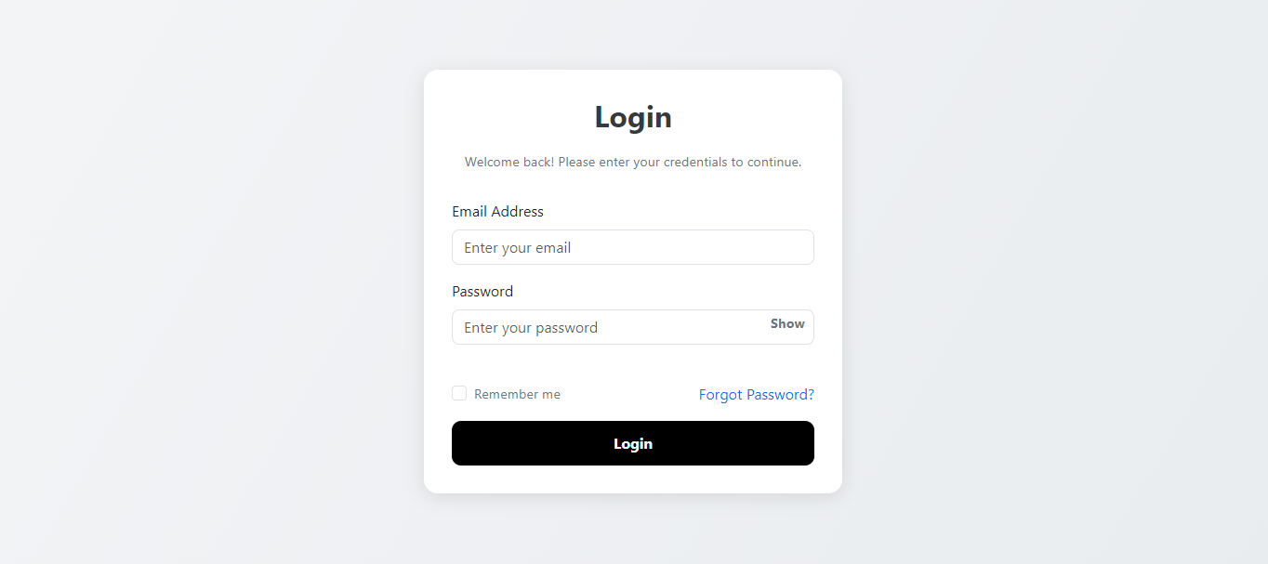

* Home Page

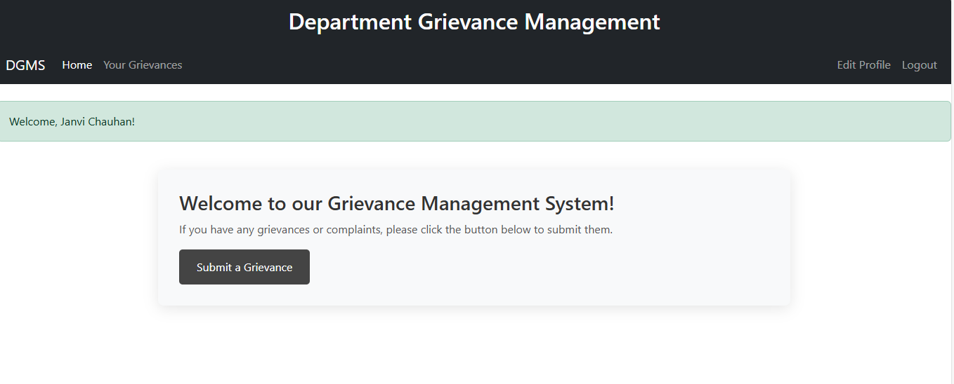

* Submit Grievance Form

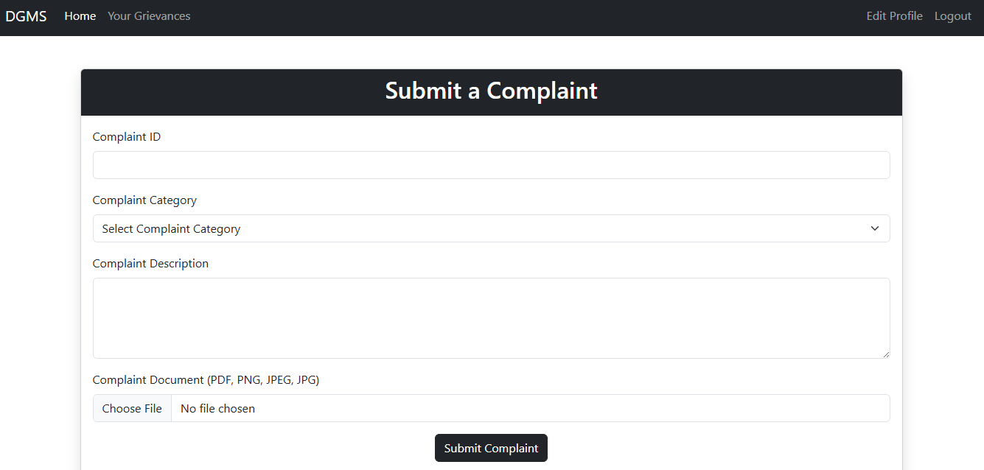

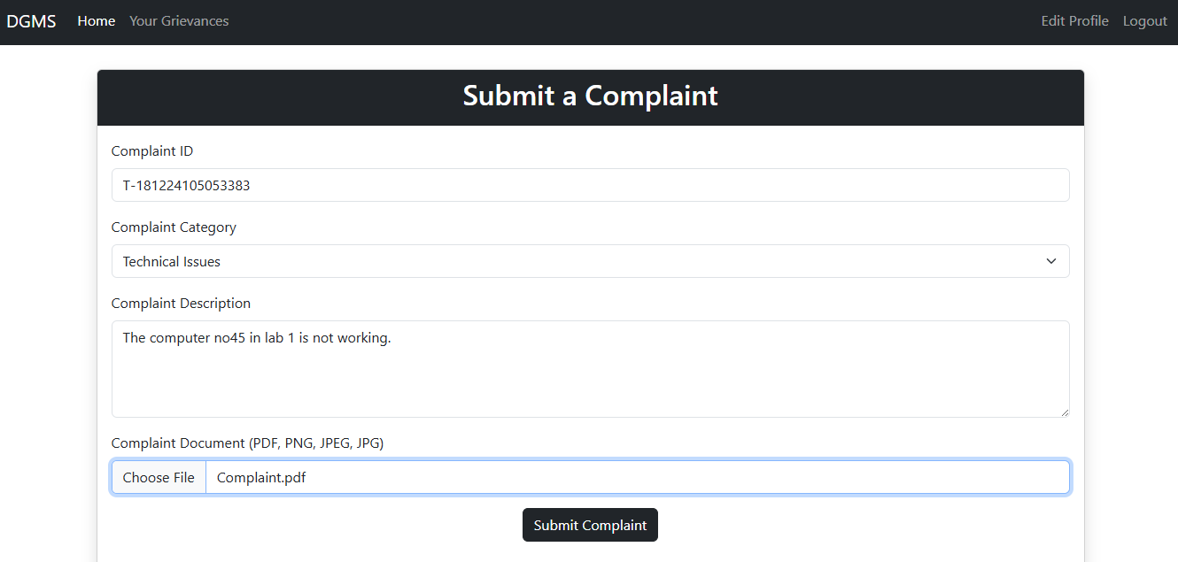

The **Complaint Submission Form** allows students to submit their complaints easily and track their progress with a unique auto-generated Complaint ID. It also supports file uploads with restrictions, ensuring an efficient process.

**Form Fields and Features**

1. **Complaint ID**:
   * Automatically generated based on the selected complaint category.
   * Helps students track their complaint status.
2. **Complaint Category**:
   * Dropdown menu for students to select the appropriate complaint category.
   * The selection triggers the generation of a unique Complaint ID.
3. **Complaint Description**:
   * A text area for students to provide detailed information about their complaint.
4. **Complaint Document Upload**:
   * Students can attach files (PDF, PNG, JPEG, JPG) to their complaint.
   * **File Size Limit**: 500 KB maximum.
5. **Submit Complaint Button**:
   * Once the form is completed, students submit their complaint for processing.

**Key Features**

* **Auto-Generated Complaint ID**: Linked to the selected category, simplifying complaint tracking.
* **File Upload Support**: Allows PDF, PNG, JPEG, and JPG files with a size limit of 500 KB.
* **User-Friendly**: Designed for easy navigation and use by students.

**Error Handling**

* **File Size**: Prompts user if the uploaded file exceeds the 500 KB limit.
* **Invalid File Type**: Displays an error if the uploaded file is not a supported type.
* **Empty Fields**: Basic validation ensures all required fields are filled before submission
* Submitting Grievance Successfully

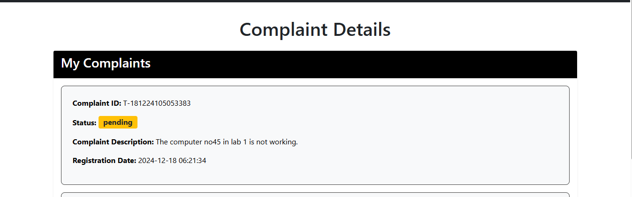

### My Complaints Section

This section displays key information about a submitted complaint, helping students track its status and progress.

1. **Complaint ID**: A unique identifier for the complaint, used for tracking and reference (e.g., T-18124105053383).
2. **Status**: Shows the current status of the complaint, such as Pending, In Progress, or Resolved.
3. **Complaint Description**: A brief summary of the issue reported by the student (e.g., "The computer no45 in lab 1 is not working").
4. **Registration Date**: The date and time when the complaint was submitted (e.g., 2024-12-18 06:21:34).

This section provides students with real-time information about their complaint, ensuring transparency and easy tracking.

* Edit Profile

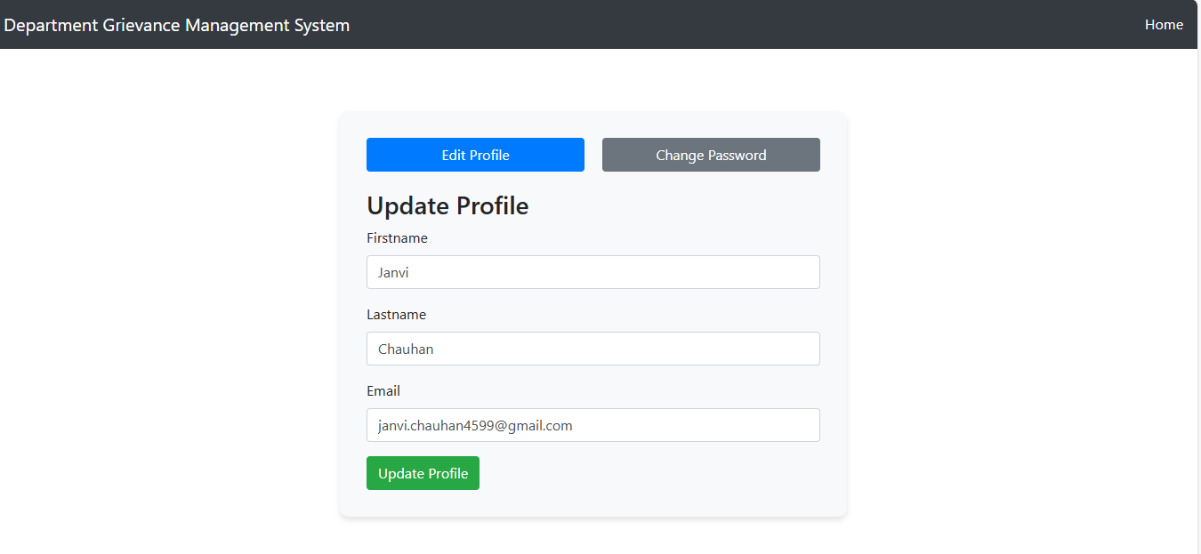

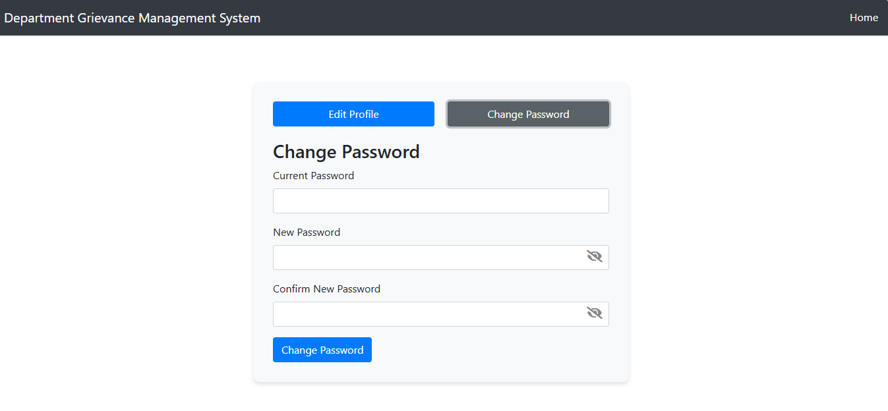

* Faculty Dashboard

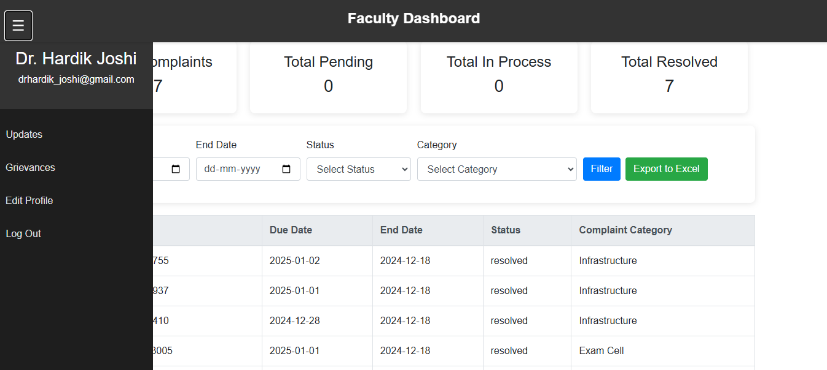

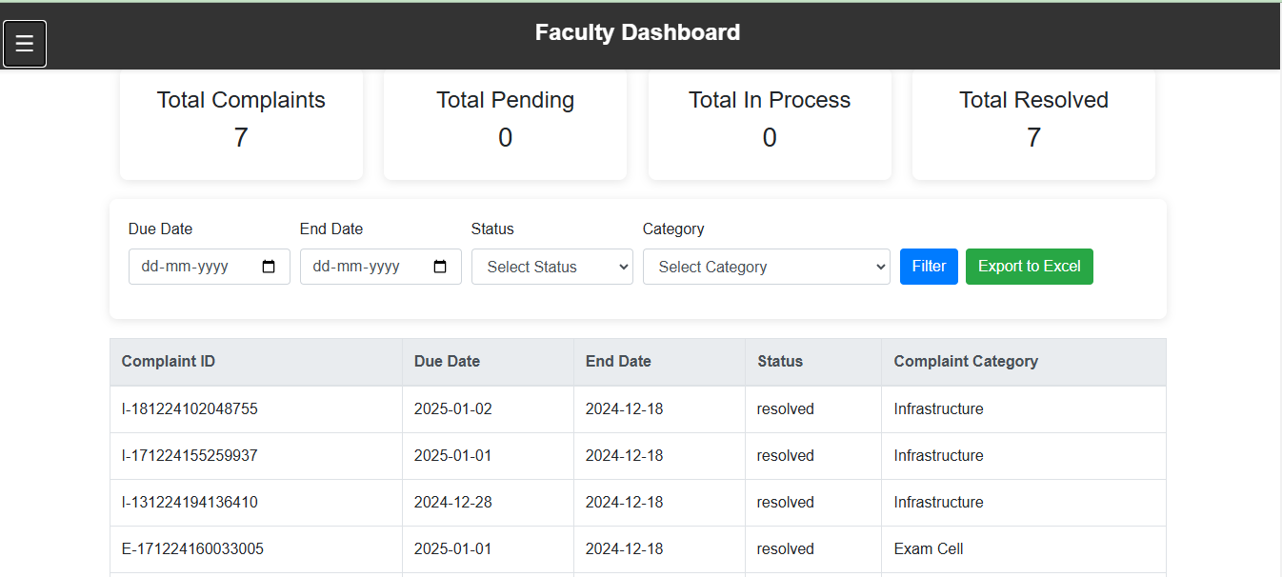

Dashboard for Faculty  
An overview of complaints made against faculty members is available on the Faculty Dashboard:  
  
Overview of Complaints: Shows the total number of complaints, including the numbers for complaints that are pending, being processed, and resolved.  
  
Reports: Provides teachers with the ability to view comprehensive complaint reports and export them to Excel for additional analysis.  
  
Faculty can effectively monitor and handle concerns with the aid of this dashboard.

* Filter Reports

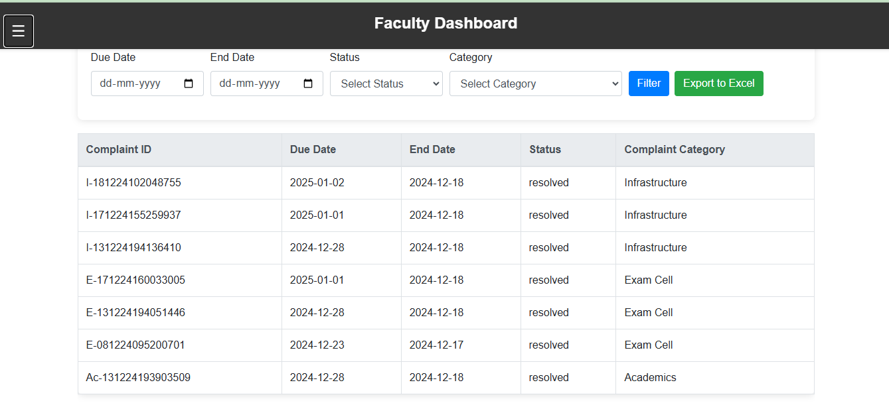

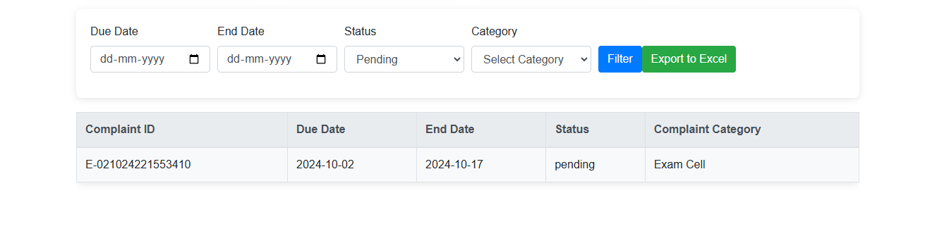

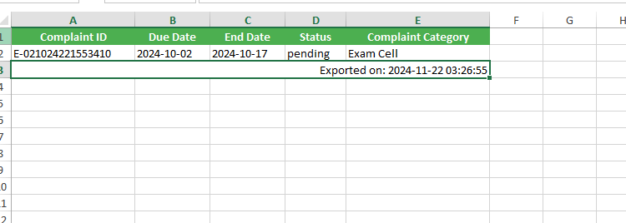

* Grievances Assigned list

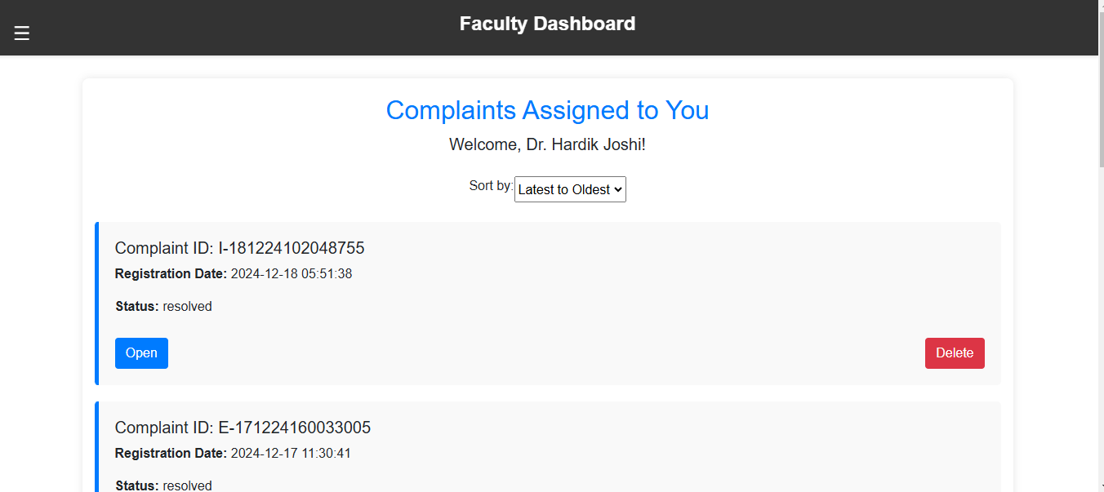

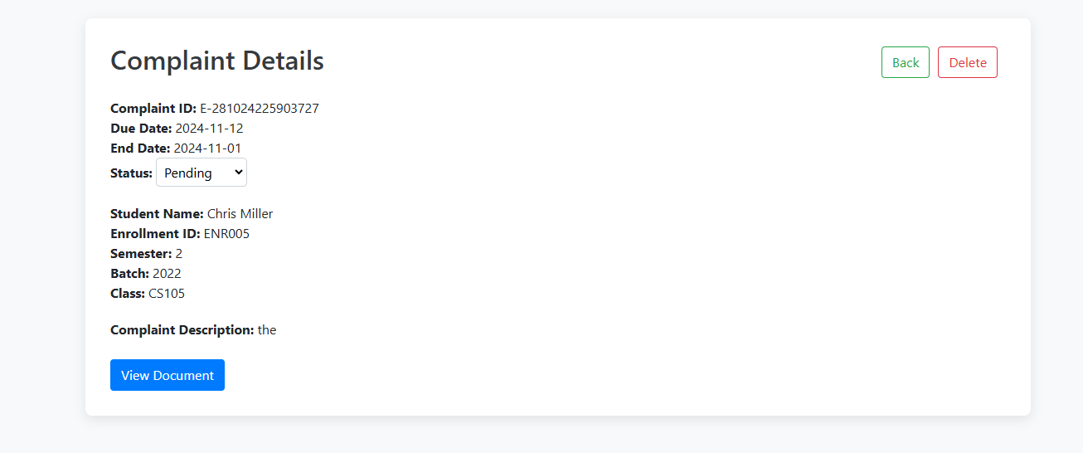

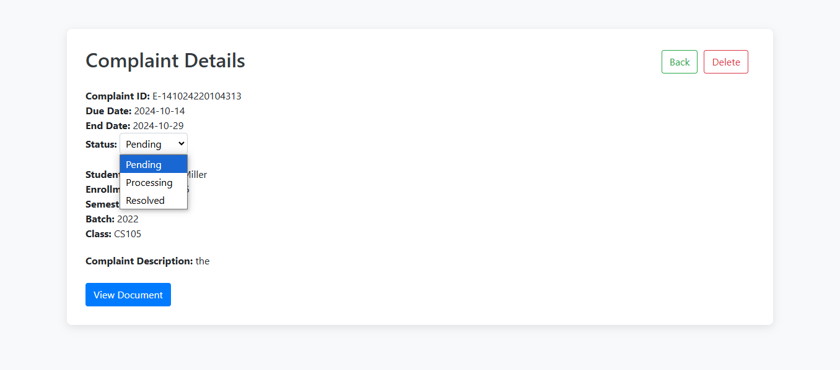

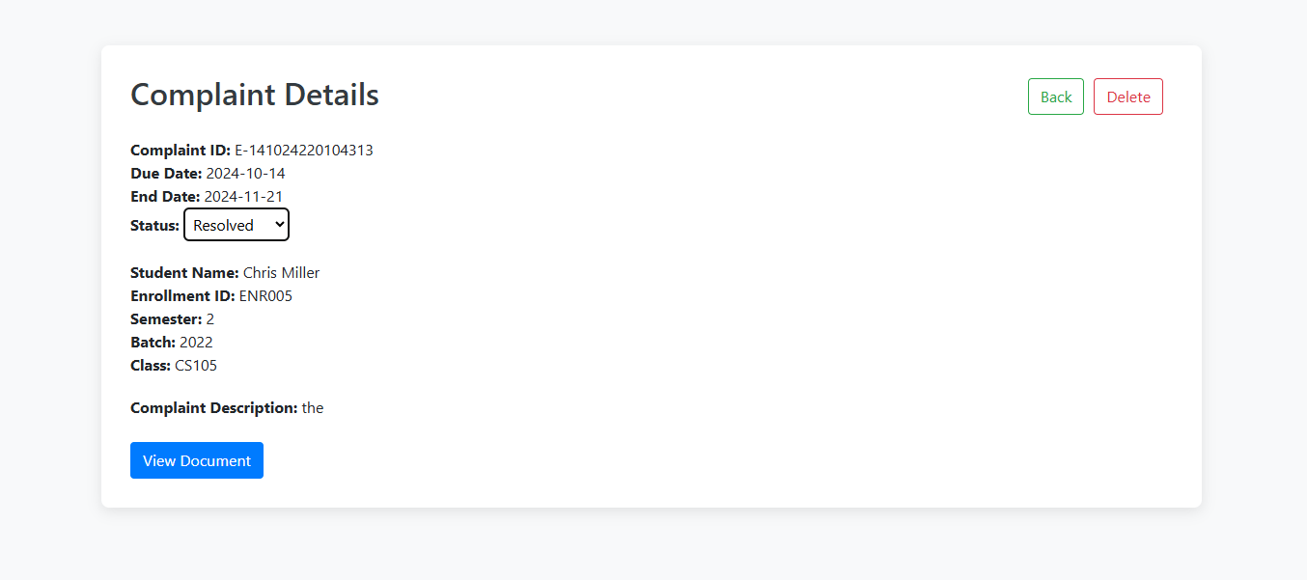

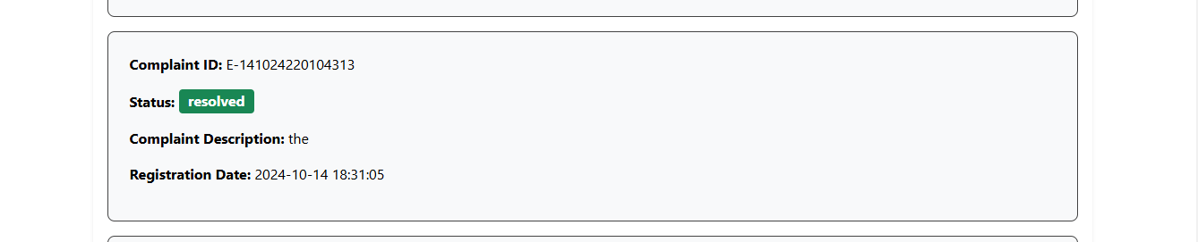

Faculty can modify the complaint status from Pending to Resolved on the Faculty Dashboard. Students are able to monitor the status of their complaints in real time since the update is instantly reflected on the Student Side.

* Complaint Document

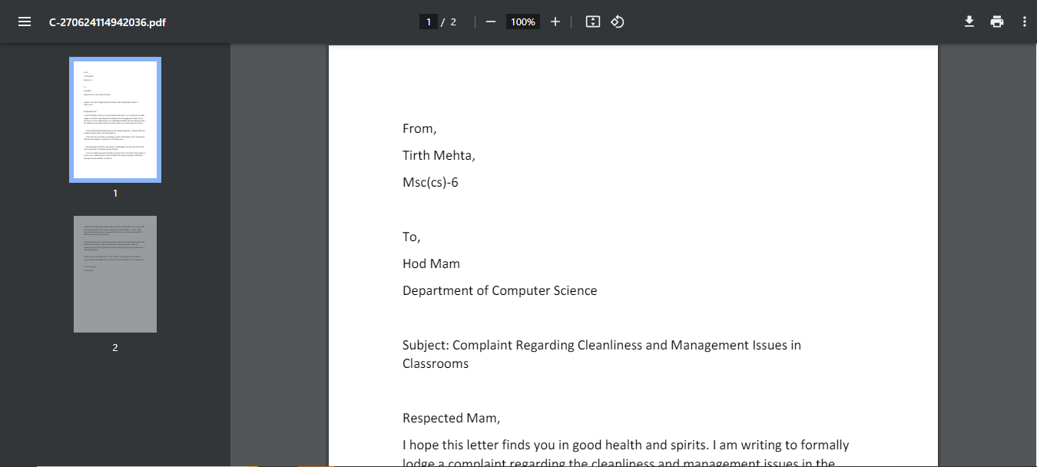

* Admin Dashboard

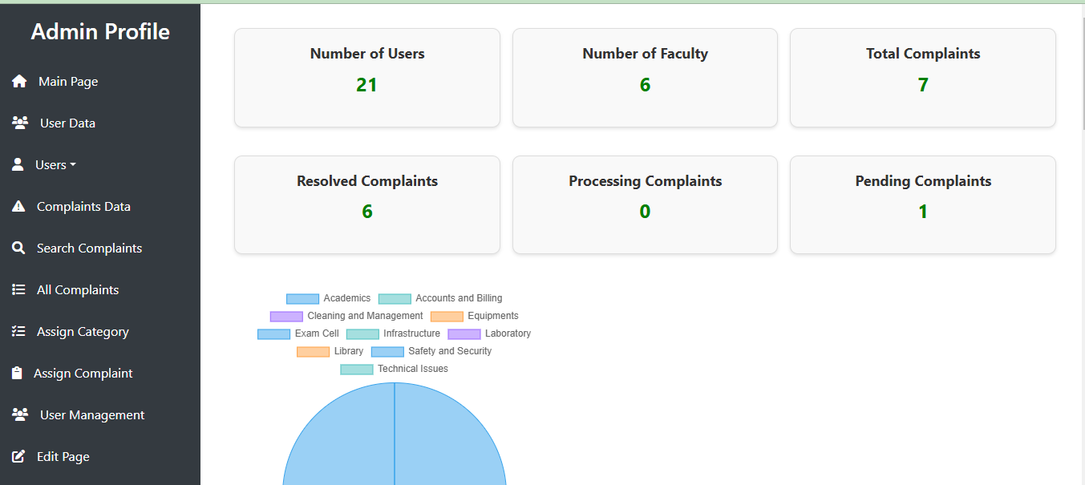

* Users

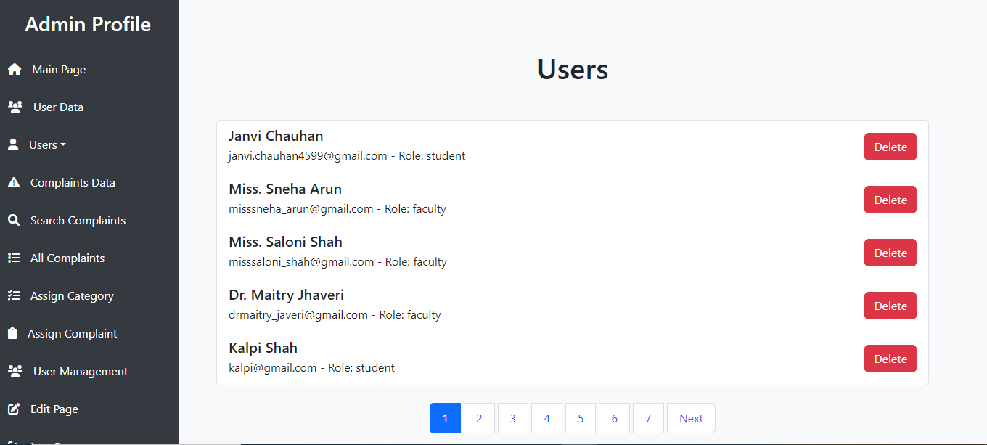

* Faculty Users

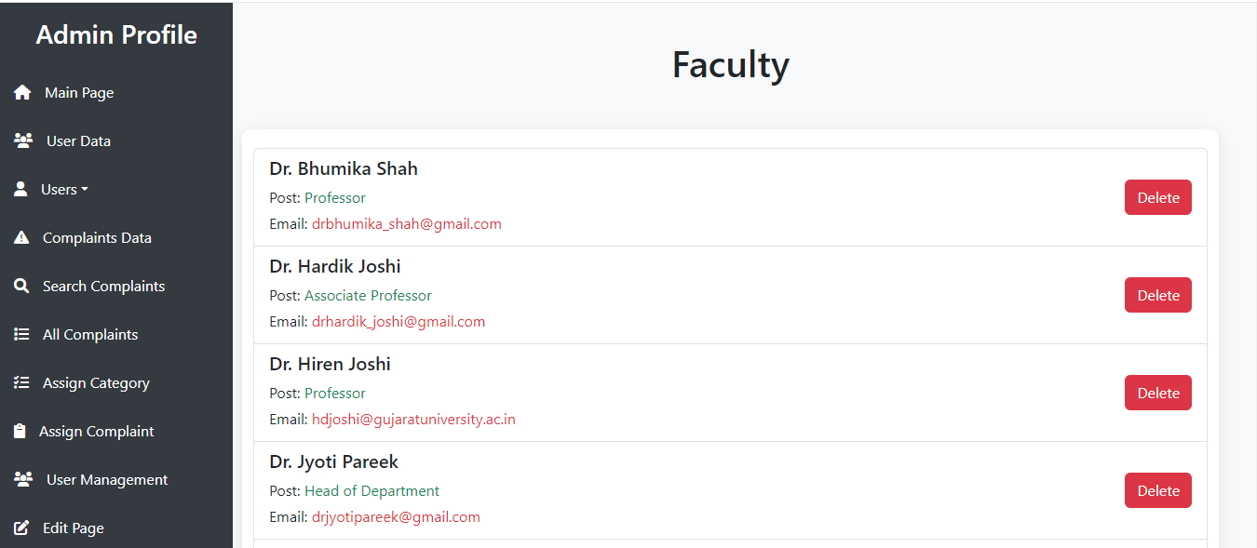

* Student Users

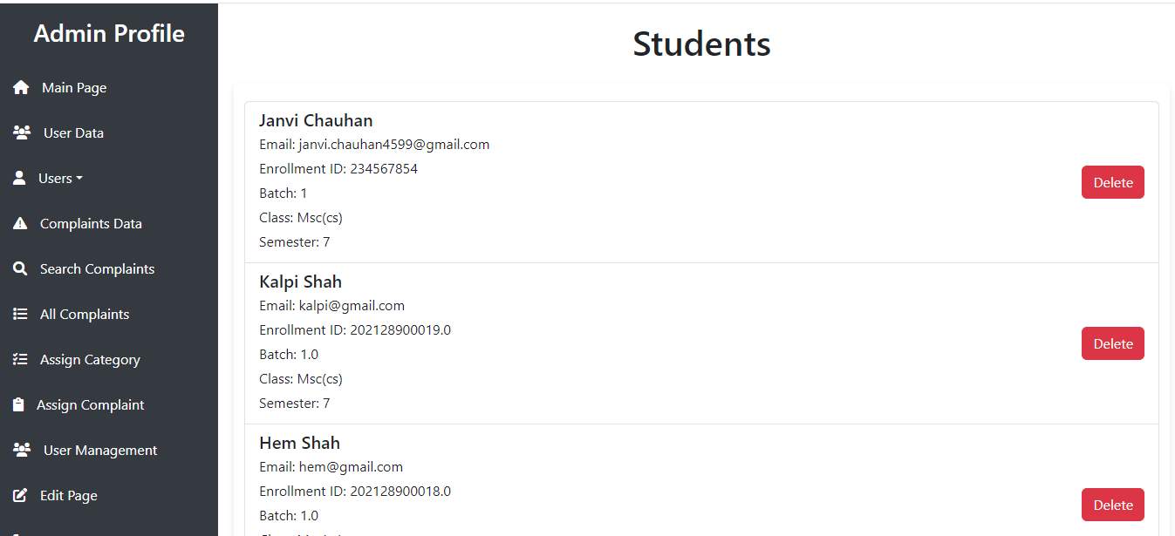

* Grievances

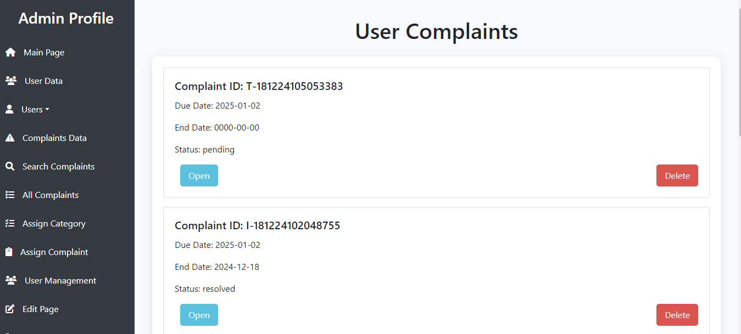

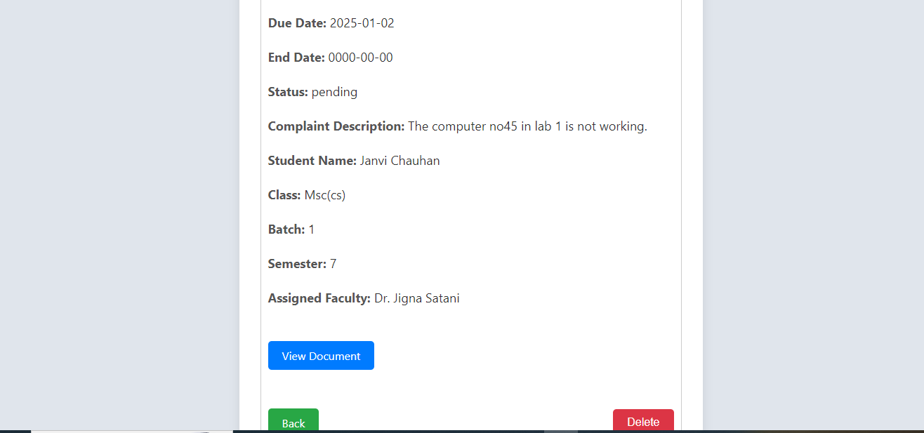

Search Complaints

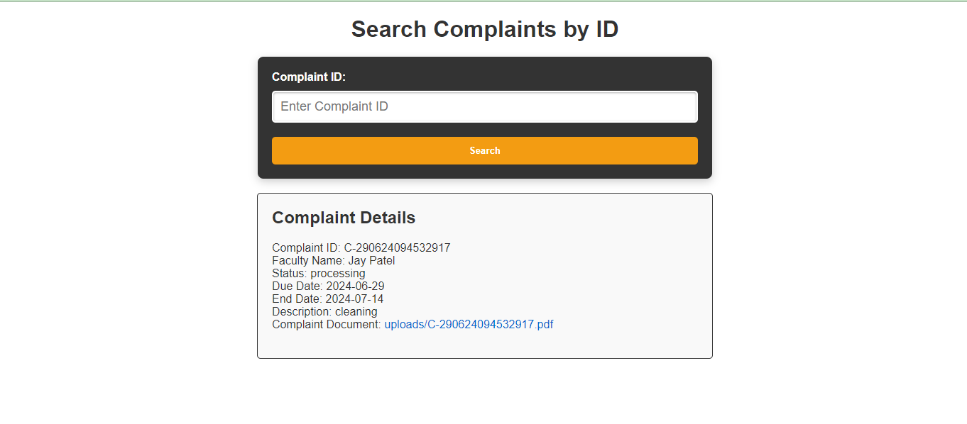

* Filter Reports

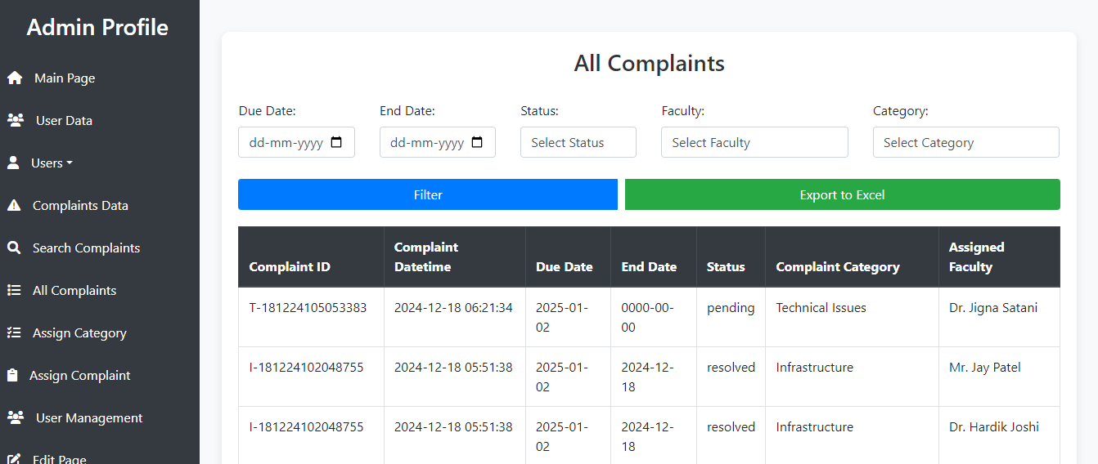

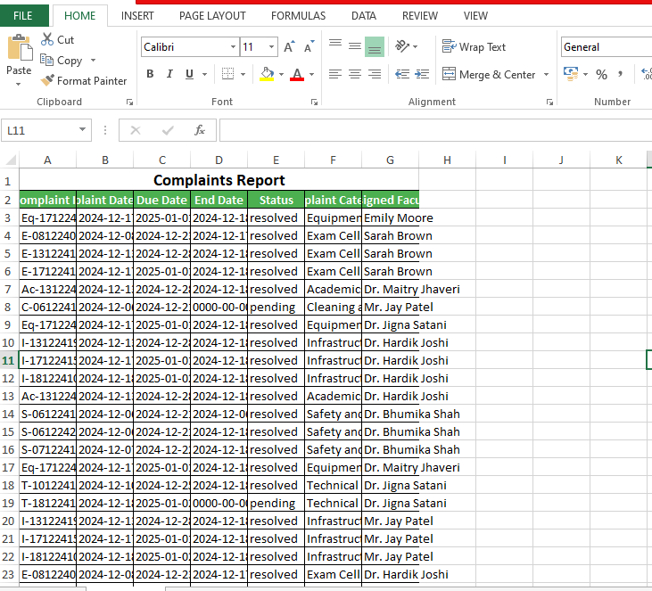

* Assign Complaints to Faculty

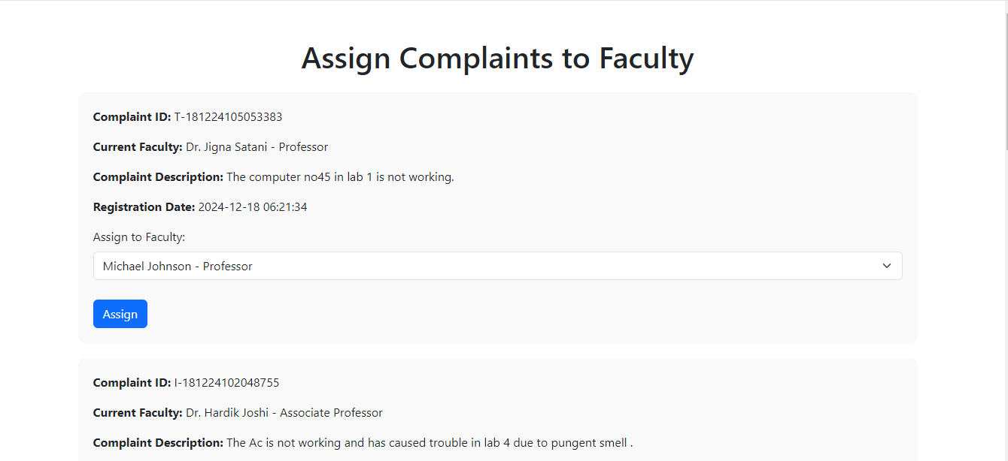

Faculty Assignment to Complaint  
Using the admin panel, the administrator can designate any faculty member to handle any issue. This feature makes sure the appropriate faculty member is in charge of resolving a particular complaint by enabling the administrator to dynamically assign or modify the faculty handling it.

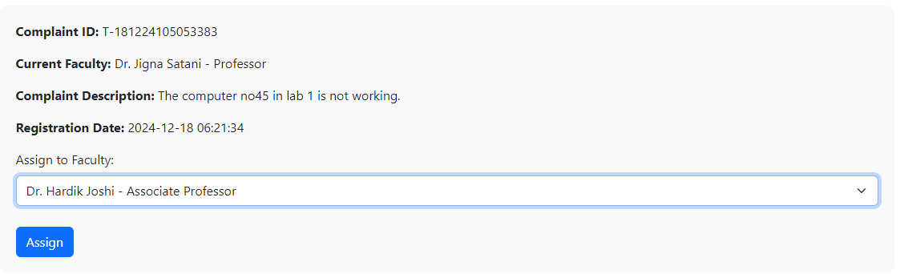

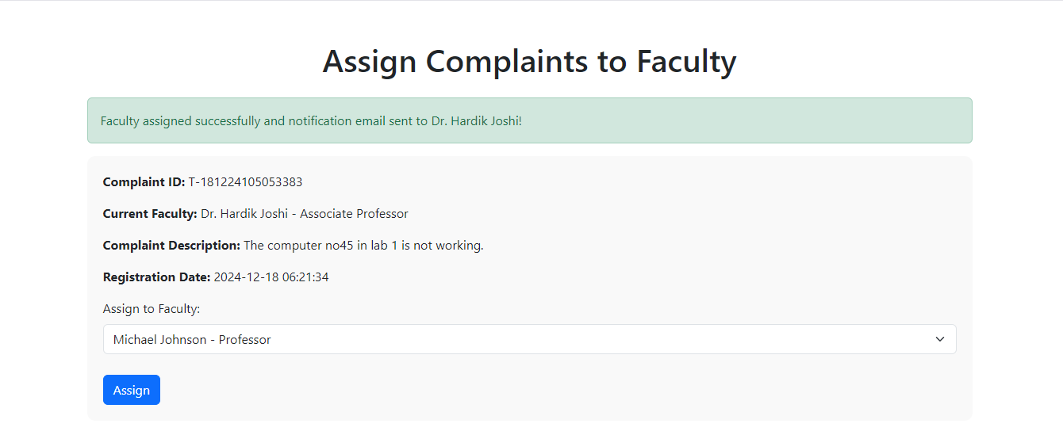

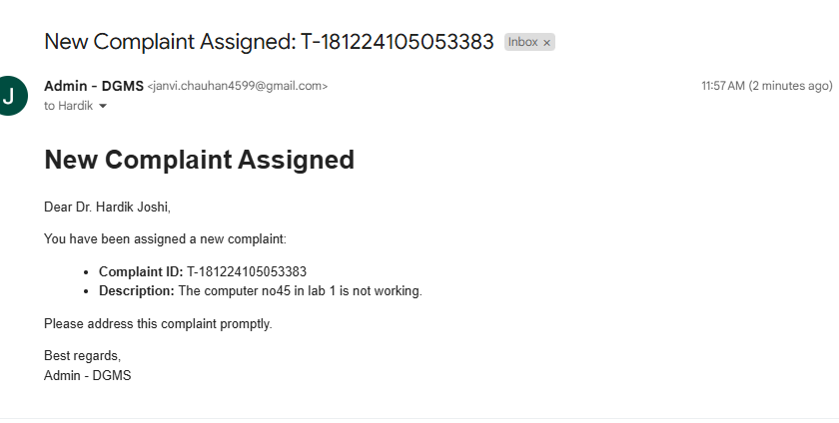

Faculty Notification  
A faculty member is automatically notified when the administrator assigns them a complaint. This guarantees that the faculty is aware of the new complaint assignment and can act quickly to address it.

* Assign Category to Faculty

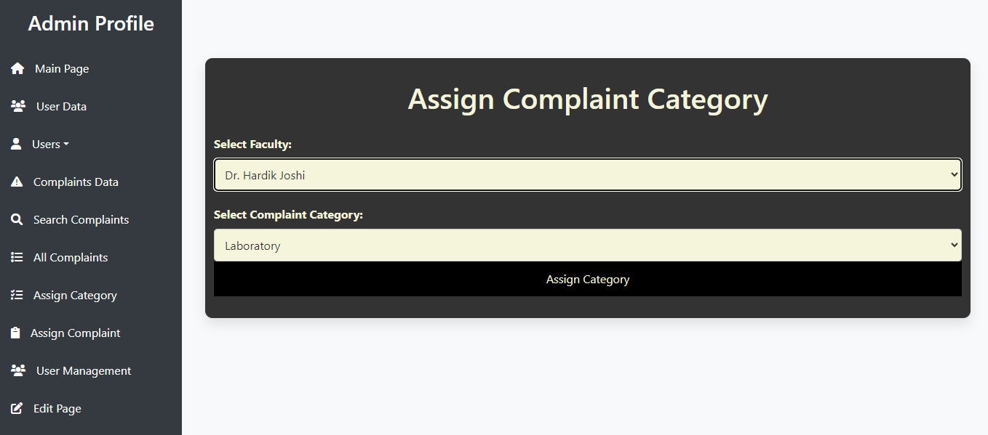

* User Management

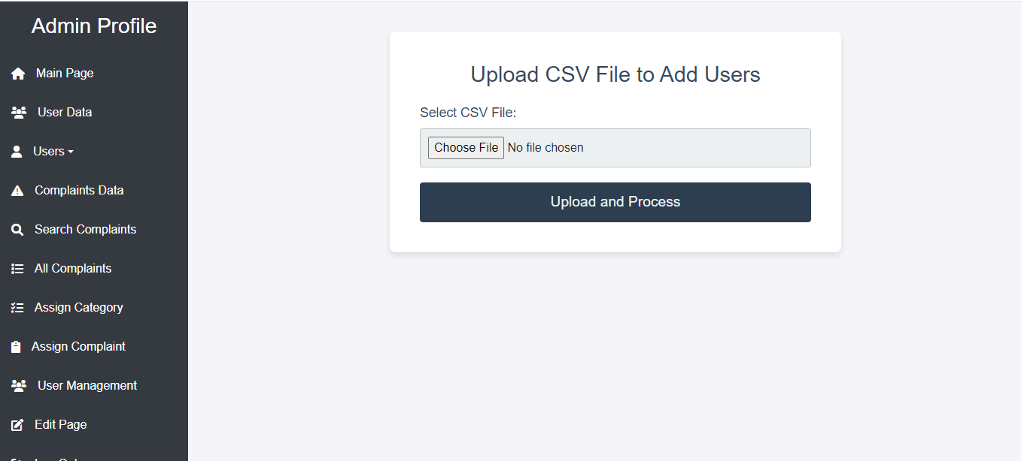

**Conclusion**

Department of Computer Science

2

* The system is beneficial for departmental level and interaction of the users.
* With its ability to track grievances and manage them accordingly and to improve the overall academic experience by providing a streamlined, efficient, and transparent mechanism for handling complaints.
* This platform not only improves the efficiency of the grievance handling process but also fosters a culture of accountability and transparency within the department. Additionally, the ability to filter and generate detailed reports from the data collected enables the department to identify trends, make data-driven decisions, and continually improve the quality of its facilities and services.
* Overall, the Department Grievance Management System is a significant step towards creating a more supportive, responsive, and conducive environment for all members of the academic community. By addressing and resolving grievances promptly and effectively, the system contributes to a better, more harmonious academic environment.

**Future Scope**

**Cloud Deployment**

* Plan to host the application on cloud platforms like AWS, Google Cloud, or Azure for scalability and reliability.
* Enable auto-scaling to handle increasing user traffic.

**Improved Security**

**Bibliography**

Department of Computer Science

2

* <https://epfigms.gov.in/grievance/grievancemaster>
* <https://www.w3schools.com/>
* <https://pgportal.gov.in/>